Scratch Environmental preparation

1. operating system

Suitable for Win7、Win8.1、Win10

2.Brower

FireFox

Download link：http://ftp.mozilla.org/pub/firefox/releases/

3. Programming tool

arduino-1.8.8-windows

4.HFS server

hfs.exe

Download link：http://www.rejetto.com/hfs/?f=dl

Arduino tool configuration

1.Connect the Spresense board to your computer's USB port

2. After installing the Arduino IDE, start it with administrator privileges;

3.Go to File > first choice > setting > Additional Developer Manager URL：

<https://github.com/sonydevworld/spresense-arduino-compatible/releases/download/generic/package_spresense_index.json>

4. If you need an agent online，Go to File > first choice > network > Manual proxy settings

5.Go to tools > Board menu > Development board manager，Entering the Spresense keyword will appear: Spresense Referrence Board by Spresense Community→Select version：1.1.3→install

6.Go to File > Examples > Firmata > Standard Firmata

7.Select your Spresense board from the Tools > Board menu

8.Select your serial port from the Tools > Port menu.

On Mac, it's something like /dev/tty.usbmodem-1511.

On Windows, it's probably the highest-numbered COM port.

(Or unplug the Spresense, check the menu, and then replug your Spresense and see what new port appears.)

9.Modify 【C:\Program Files (x86)\Arduino\libraries\Firmata\Boards.h】，Append the following before executing [#else]：

// SPRITZER (TBD)

#elif 1

#define TOTAL_ANALOG_PINS NUM_ANALOG_INPUTS // 6

#define TOTAL_PINS 35 // 29 digital + 6 analog

#define MAX_SERVOS NUM_DIGITAL_PINS // All pins can be servo with SoftPWMservo

#define VERSION_BLINK_PIN PIN_LED0

#define IS_PIN_DIGITAL(p) ((p) >= 0 && (p) <= 28)

#define IS_PIN_ANALOG(p) ((p) >= 29 && (p) <= 35)

#define IS_PIN_PWM(p) ((p) == 6 || (p) == 5 || (p) == 9 || (p) == 3) // digitalPinHasPWM(p)

#define IS_PIN_SERVO(p) IS_PIN_DIGITAL(p)

#define IS_PIN_I2C(p) ((p) == SDA || (p) == SCL)

#define IS_PIN_SPI(p) ((p) == SS || (p) == MOSI || (p) == MISO || (p) == SCK)

#define PIN_TO_DIGITAL(p) (p)

#define PIN_TO_ANALOG(p) (p) - 29

#define PIN_TO_PWM(p) (p)

#define PIN_TO_SERVO(p) (p)

10.Click the upload button

HFS server

1. After the download is complete, execute HFS.exe

2. Drag and drop the file spresense_extension.js to [Virtual file system]

Browser configuration

1. The Firefox version is 35.0.1. This is a relatively stable version of ScratchX currently running. To prevent the browser from automatically updating, set it to [Do not check for updates].

2. Install the latest version of Flash Player. The current official latest version: 32.0.0.156.

Need to pay attention when downloading：

1）Select the corresponding operating system；

2）Select version：FP 32 for Firefox - NPAPI

3. Install plugin：ScratchDevicePlugin.msi

1）Download link：https://scratch.mit.edu/info/ext_download/

2）Select：Windows（Other browers）

ScratchX Running

1. Run the Firefox browser and open：<http://scratchx.org/#extensions>  
2. Select the Arduino module→【sample project】，Pop up the Warning window and select【I understood，continue】

3.click ，Set the plugin(Adobe Flash、Scratch Device) to [Long-term permission]

4. After entering the [scratchx.org/#scratch] page，Go to【File】→【Load Project】→【Select local file：Spresense_LED_Blink9.sbx】→【OK】

5. Connect the LED to the PIN9 of Spresense as shown below and connect the resistor to GND.

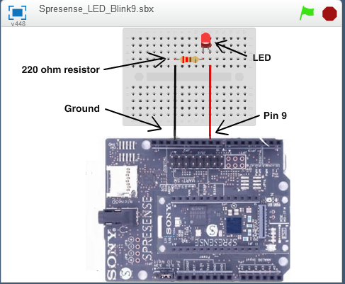

6.click【Load Experimental Extension】，Fill in the [spresense_extension.js] address in the tool HFS into the [Open an Extension URL] window. Example：http://10.1.4.173/spresense_extension.js；In the pop-up window, select：I understood，continue

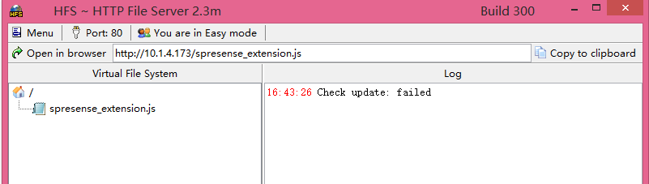

7. Waiting for the light to turn green indicates that the connection is successful and you can control the 【Spresense development board】.

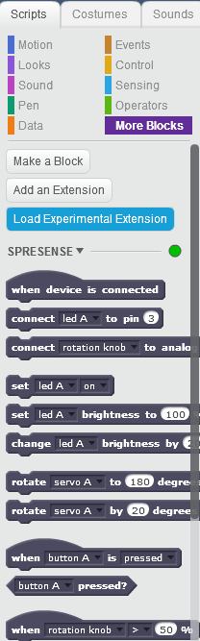

Abnormal situation：

If you cannot open the http://scratchx.org/#scratch webpage, always indicate [Disconnected], and the [Scratch Device] is not displayed in the plugin, you need to uninstall the installed Scratch Device Plugin and re-download and install it. After the installation is successful, restart the Firefox browser.